End-of-chapter questions
Short answer

1 Reflect on why there was no recognition of Aboriginal and Torres Strait Islander land rights in the Australian colonies.

2 Why did South Sea Islander people return to Australia for a second or third time?

3 In what ways was Australian democracy more advanced than that in Britain and the United States?

4 Explain why women wanted the right to vote.

5 Describe the White Australia Policy.

Source analysis
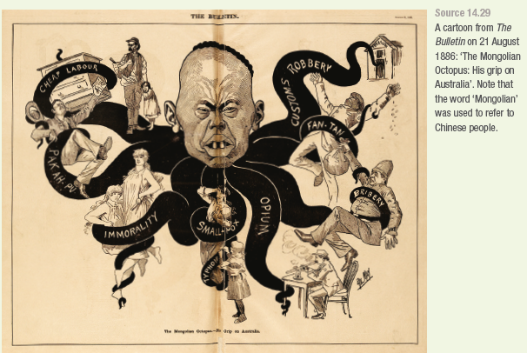

1 In the cartoon, what is the octopus doing to the different Australian people?

2 Research the meaning of ‘Fan-Tan’ and ‘Pak Ah-Pu’.

3 Explain why there is a chest of drawers in the top left-hand corner.

4 How is the Chinese man presented in this cartoon?

5 Compare his face with that of Quong Tart (see Source 14.12).

6 Compare this cartoon with the one at the end of Chapter 12 (see Source 12.23) depicting the Chinese man barred from entering the United States.

7 Given that European Australians had taken over all the country and land of Indigenous Australians by 1886, could you draw an octopus figure with eight arms presenting an Indigenous view of European Australians as gripping the Australian landmass? With each arm, illustrate one of the damages the Europeans caused to Indigenous Australians.

Extended response question
Which groups were the main winners and losers in the making of the Australian nation between 1788 and 1914? Try to assess what each group won or lost in the process, and determine the level of their successes, failures, privileges or difficulties.

