**Models useful for completing different parts of Assignment, Part 1.**

|  |  |  |
| --- | --- | --- |
| I have keyed models and page numbers into the different ‘bits’. Not all will be useful or used by students. But this is what is available to them if they look in the text. | | |
| Area | Model | Model |
| General overview – strategic planning process Fig. 2.1 (p.37) | Macro analysis  PLC of product in country – Fig 8.9 (p.279)  definition of competitive space – market boundaries | PEST – Table 3.1 p.67 and Table 3.2 p.68  Trend analysis Figs 3.1 $ 3.2  Market attractiveness models and requirements  PLC – Table 8.1 p. 172 gives stages  PLC – Table 6.1 p. 125 gives KSF for each stage  PLC p.169-9 gives adopter groups  PLC p. 80-4 gives competition through the stages  PLC p. 171-2 gives international PLC  PLC Table 12.1 p.251-4 gives business structures appropriate for each stage of PLC  - BCG Fig. 7.3 (p.148)  -Multifactor portfolios (e.g., GE Matrix, Shell Matrix) – generic one available Fig.7.4 p. 153  - also the excel spreadsheets available  Competition models (Porter’s Generic Strategies) – (p.33-4)  Barriers to entry (Porter’s Five Forces) – Fig. 4.5 (p.93-5)  Porter’s value chain Fig.6.2 p.130-1 |
| Customers | Market models – perceptual mapping Fig 4.4 (p.91) | Segmentation models – see chp 5, p.107-13  Market share metrics p.113-16 |
| Competition | Degree of competition (Porter’s Five Forces) – Fig. 4.5 (p.93-5)  Competitive stance/market position – Table 4.1 and 4.2 (p.86)  Porter’s value chain Fig.6.2 p.130-1  Market share p.85 | Key success factors (competitive strength grid) – Table 4.3 p.91  Strategic group analysis – Relative Market position Charting strategic competitor groups – Fig. 4.3 p.90 – is mirrored in Perceptual map Fig.4.4 p.91 |
| Own firm | Internal analysis  Company framework – Fig. 6.1 (p.126) | Profitability models – ROI/ROE/ROTA/ROA, Table 6.5 (p.133)  Liquidity models Table 6.2 (p, 131)  Activity ratios Table 6.3 (p.132)  Debt ratios Table 6.4 (p. 132)  Other marketing ratios (p.134)  Systems models – p.43-5, 255-6  SCA – pp. 78, 117, 125, 126, 160, 206  Porter’s value chain Fig.6.2 p.130-1 |

Note that for Question 4 of Part 1 of the Assignment, KSF can be derived from the competitive strength grid.

For Question 3 of Part 1 the Assignment, this deals with the critical issues table.

This really is a summary of the key issues that are appraised in the business environment, corporation, customer and competitor analyses (Q1 and 2). When an issue is important and affects different dimensions of the business, then it may be considered a critical issue. Students should identify these critical issues and table them with ranks or weights to order these issues. An example of an answer to this question may be:

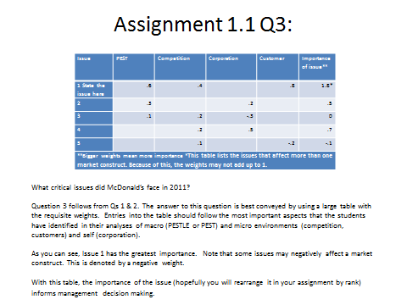

|  |  |  |  |  |  |
| --- | --- | --- | --- | --- | --- |
| **Issue** | **PEST** | **Competition** | **Corporation** | **Customer** | **Importance of issue\*\*** |
| **1 State the issue here** | .6 | .4 |  | .8 | 1.8* |
| **2** | .3 |  | .2 |  | .5 |
| **3** | .1 | .2 | -.3 |  | 0 |
| **4** |  | .2 | .5 |  | .7 |
| **5** |  | .1 |  | -.2 | -.1 |
| **\*\*Bigger weights mean more importance *This table lists the issues that affect more than one market construct. Because of this, the weights may not add up to 1.** | | | | | |